

**CPISM PROJECT**

# 

**DREAM WEAVER**

**BY STYLIST**

GROUP MEMBERS:

* YUSRA AZEEM (student: 1371006)
* LIABA ASHRAF (student: 1384789 )
* LUBABA WAJID(student: 1384791)

TABLE OF CONTENT

0

ACKNOWLEDGMENT 2

CERTIFICATE 3

OF 3

COMPLETION 3

PROBLEM STATEMENT 4

***Proposed Solution :*** 4

***Functional Requirements :*** 5

HOME PAGE 6

SCREEN SHOTS 6

REGISTRATION FORM 8

WORK BREAKDOWN CHART 12

CONCLUSION 13

# ACKNOWLEDGMENT

I would like to express my very great appreciation to **SIR MAAZ ANIS** for his valuable and constructive suggestions during the planning and preparation of our project. His willingness to give his time so generously has been very much appreciated.

I would also like to thankfull the staff of **APTECH METRO STAR** **GATE** due to this pendemic

Situation they give me the permission to visit their offices to solve my problem.



# CERTIFICATE

# OF

# COMPLETION

CERTIFICATE OF

COMPLETION

**HAS COMPLETED TO ALL THE REQUIRED STATEMENT AT THE PROJECT**

**THIS IS TO CERTIFY THAT**

**DATE**

**Yusra Azeem , Laiba Ashraf , Lubaba Wajid**

24-10-2022



**SIGNATURE**

# PROBLEM STATEMENT

The after-effects of the Covid-19 pandemic have compelled everyone to take

their businesses online. People no longer prefer visiting a market or mall for

shopping, rather they prefer searching or browsing online through the internet for

shopping new arrivals &amp; accessories. This also helps them save their time &amp; effort.

The Online fashion shopping website project proposed here will ease out the

process of shopping for the users by providing a customer-friendly experience. This

system will connect the users &amp; the fashion stylists. The users can view the stylists&#39;

profiles. The users can view the available stylists and can see their catalogues and

various collections. Based on the requirements received from the user, the stylist will

recommend products and accessories that will suit the user&#39;s interest &amp; personality.

Both the users &amp; stylists can access the system by registering themselves on the

website.

**Requirement Specification:**

This project is completely based on current fashion trend and styling. This website

will help in finding client with their customized product according to their style and

personality. These days getting a product is lot more easily than styling it and

presenting to the outer world in trendy way so, our website should bring all such

conditions under one roof and brings the best out of people. This will be a huge

benefit to all the busy personalities out there in their styling. This system comprises

email/contact facility so that users can get in touch with Stylist so that user can

describe exact requirements of the attire the user need

The Web site is to be created based on the following requirements.

1) The Home Page should be created making use of Sections with a suitable

logo, the header section can be added which will show images of

stylists/collections.

2) The site must contain the links to navigate through any category for the

information.

3) The site should display a menu which will contain the options for brief

introduction about the various stylist available, contact details of the shop and

any other information if required.

4) The information should be categorized according to the stylist names as well

as , as per their exclusive collections like summer collection…wedding

collection etc. if a User wants to see only “winter collection” or any other

then he/she can click on a Link/button/menu etc and can see only that

collection. When a user selects any particular stylist/collection, a list for that

respective will be displayed

5) A brief summary of features and other details like size/cost/fabric type etc

should be displayed on the Web Page along with the picture but detailed

Features should be stored in Individual Word documents which can be

downloaded or viewed by the User who wishes to see the same.

6) The user should also be able to compare the various products of different as

well as same stylist.

7) There should be a “Contact Us” page which will have the Address of the stylist

which should be displayed using GeoLocation API (eg. GoogleMaps) and the

email address which when clicked will invoke the local mail client from where

they can send an email.

## HOME PAGE With NAVBAR

# SCREEN SHOTS

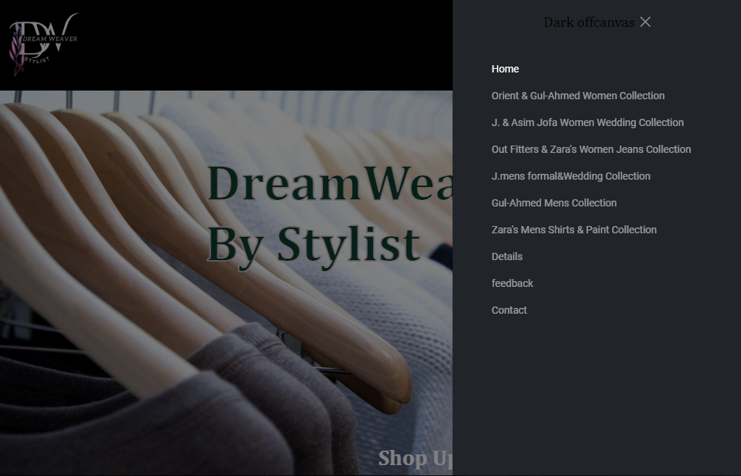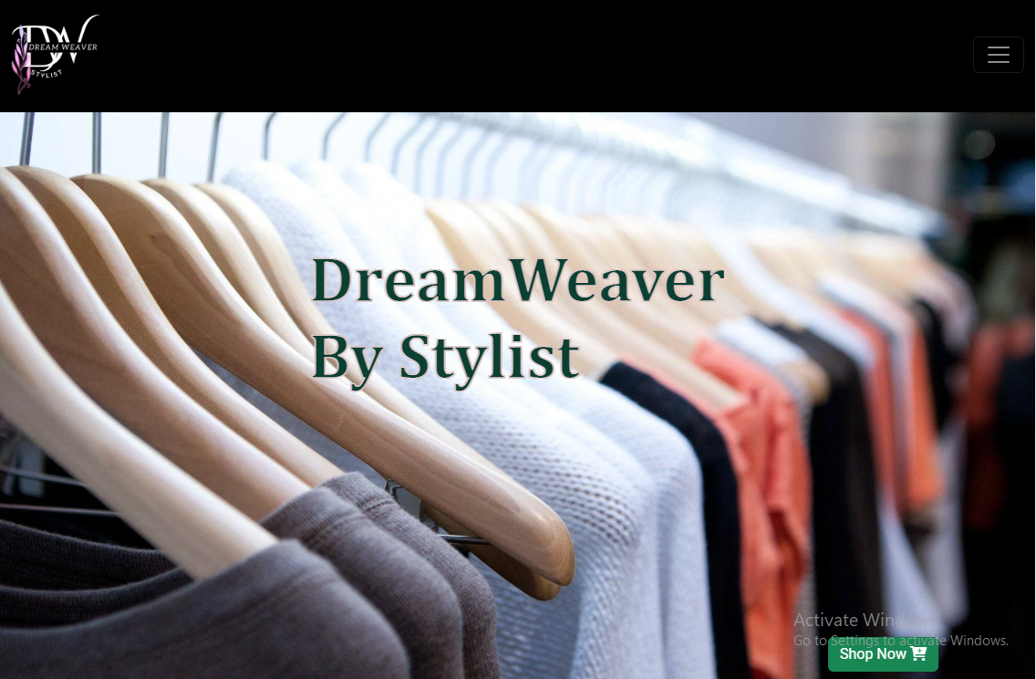

User login

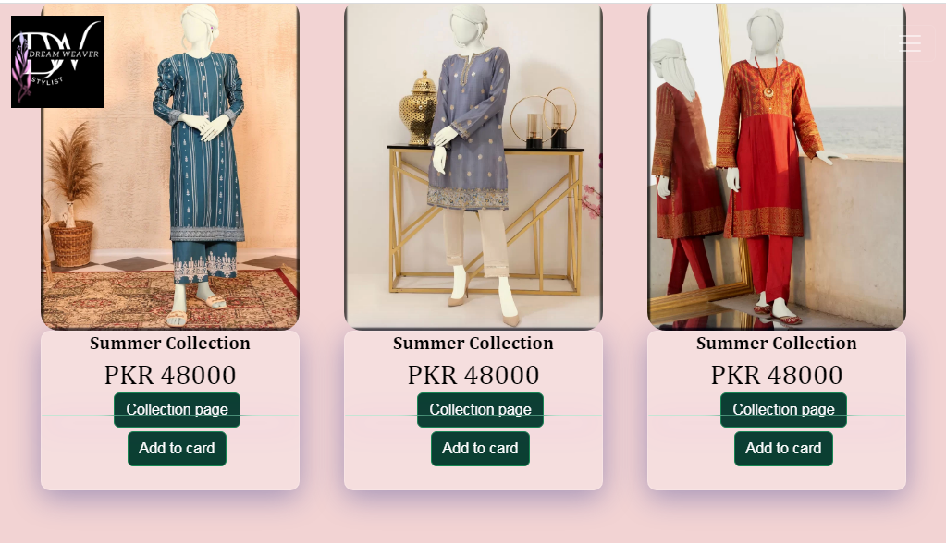

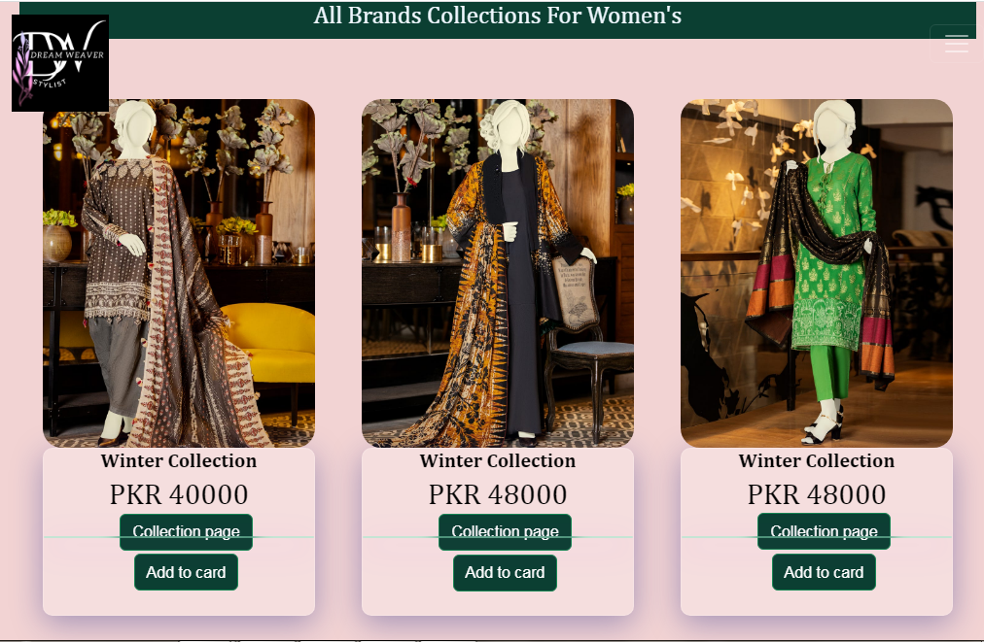

## 

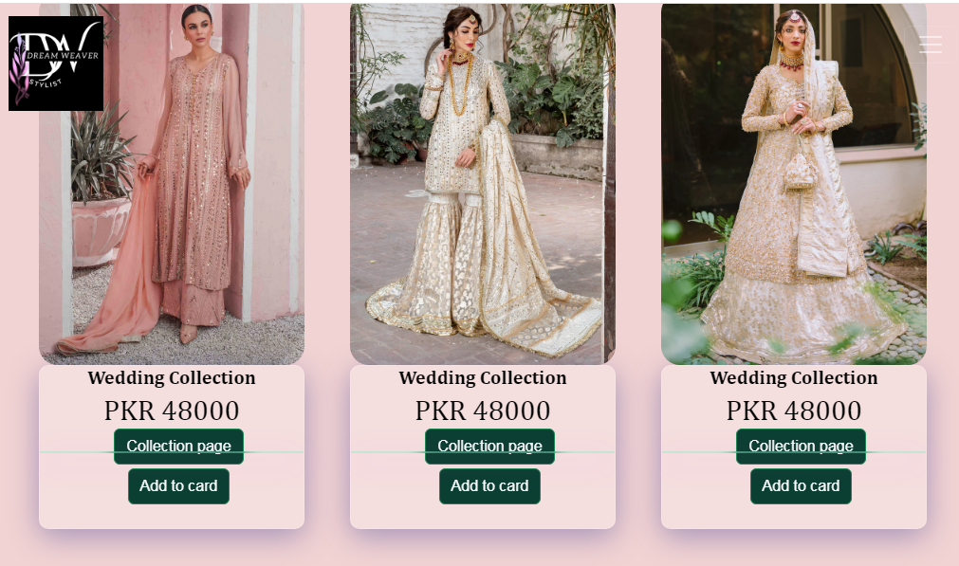

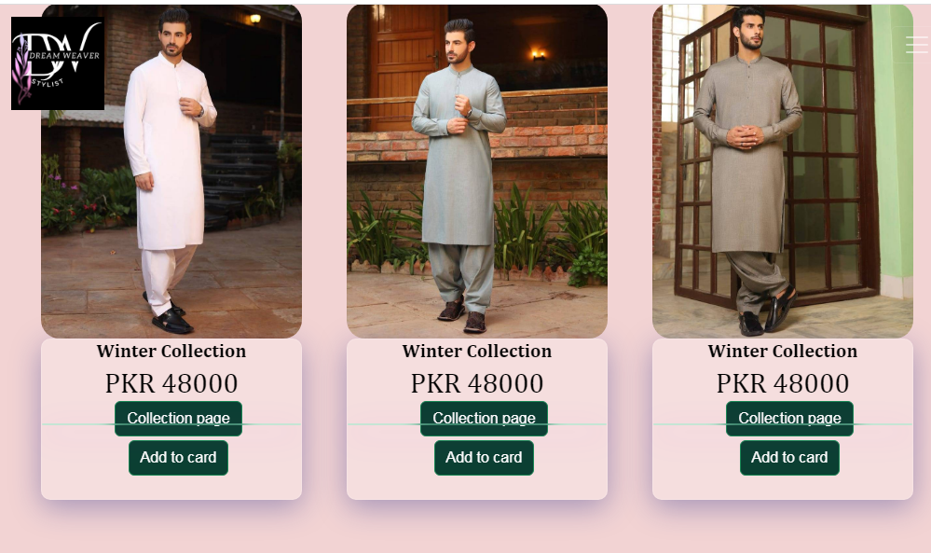

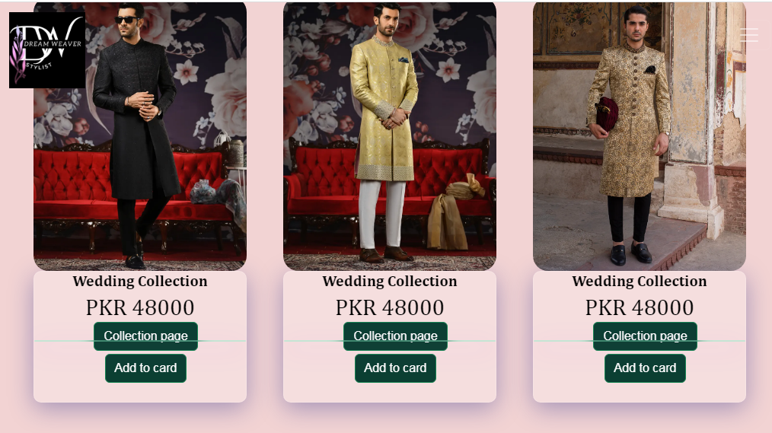

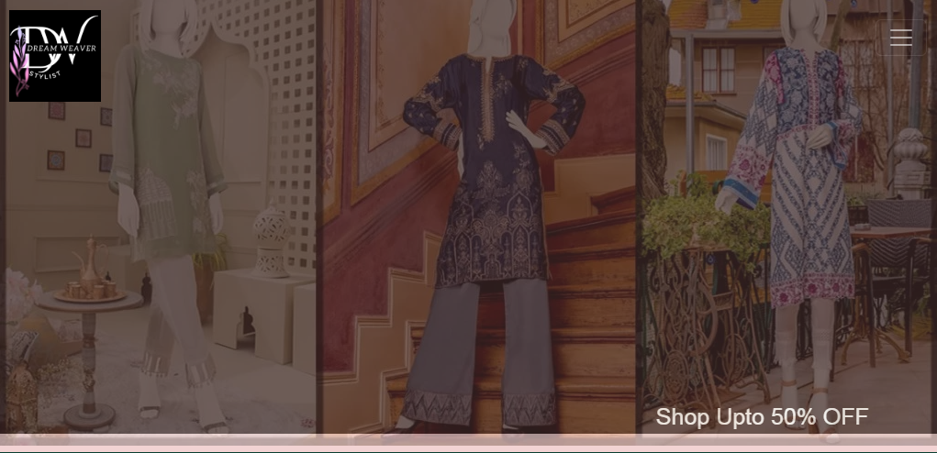

footer

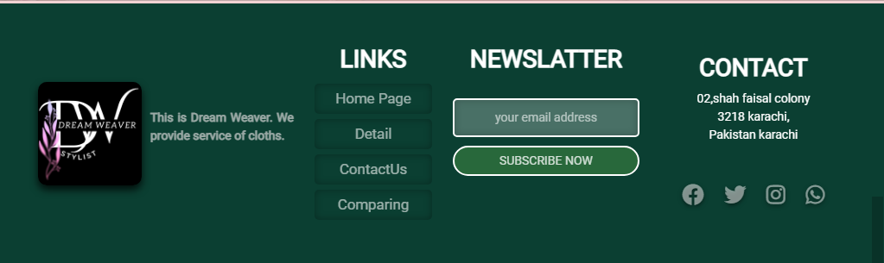

Collection Page

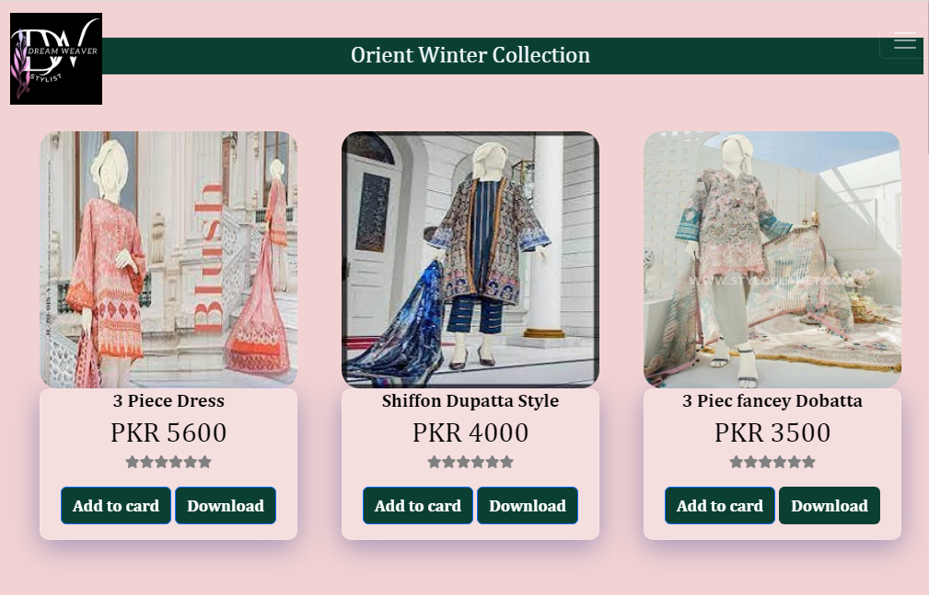

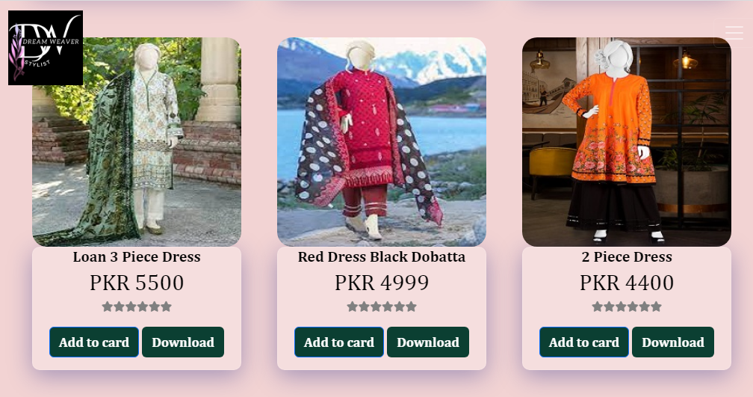

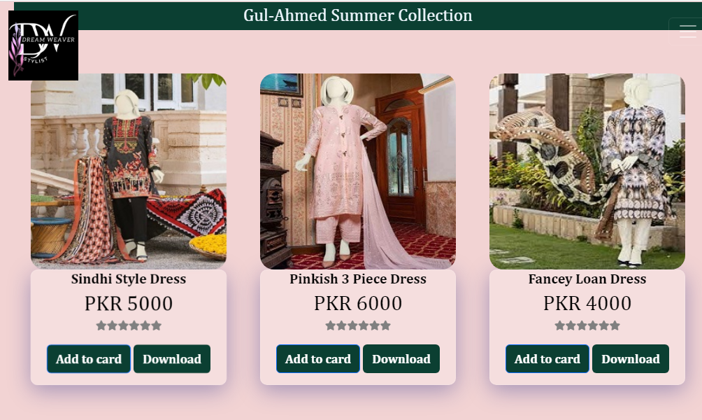

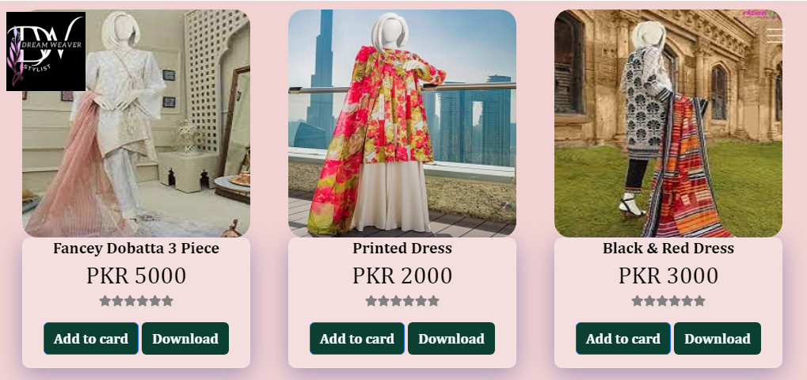

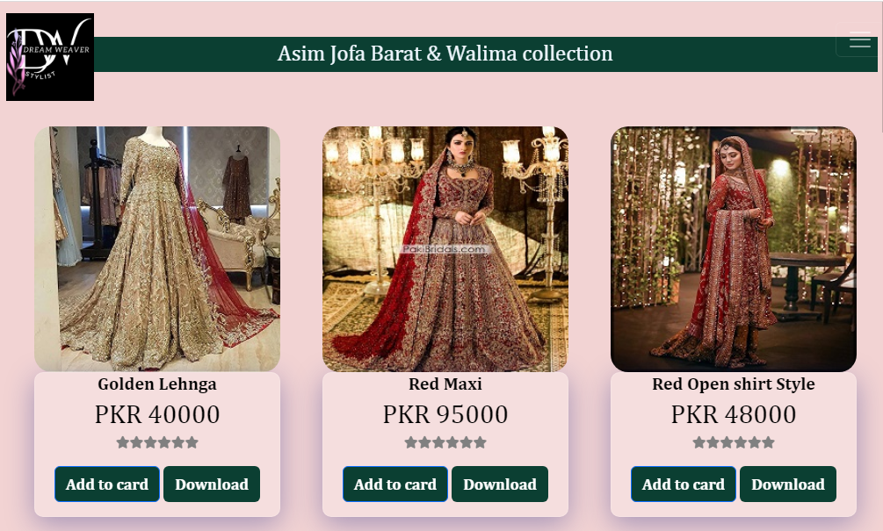

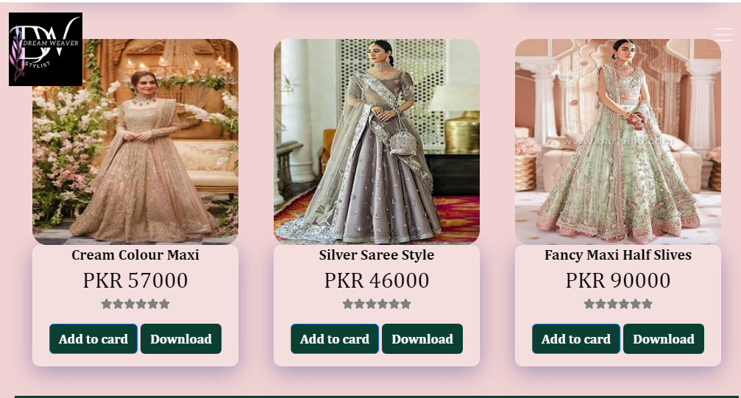

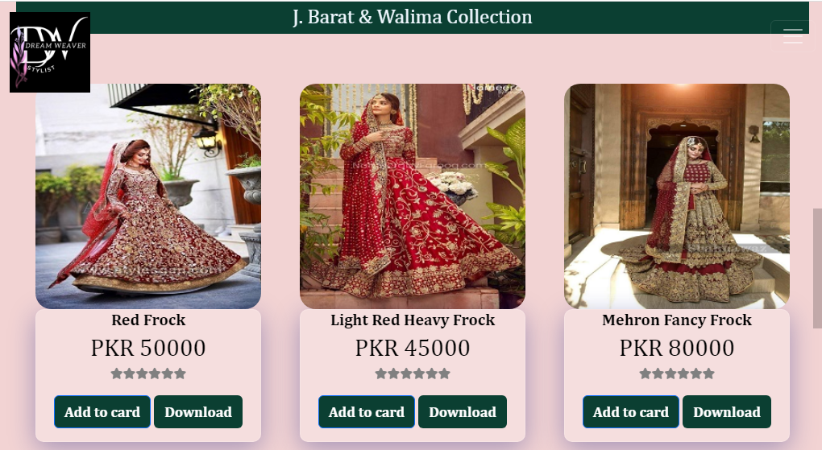

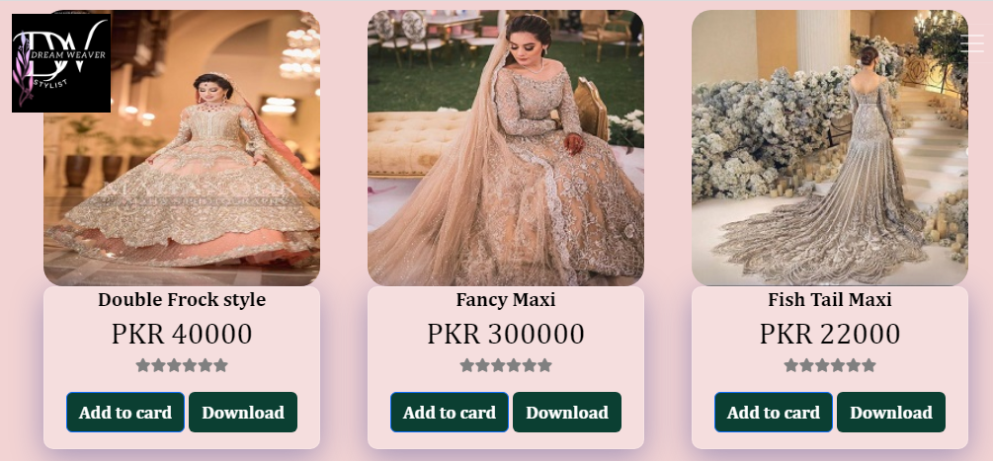

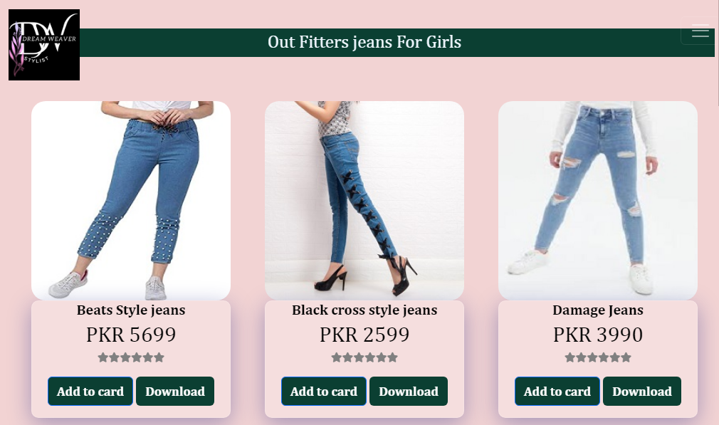

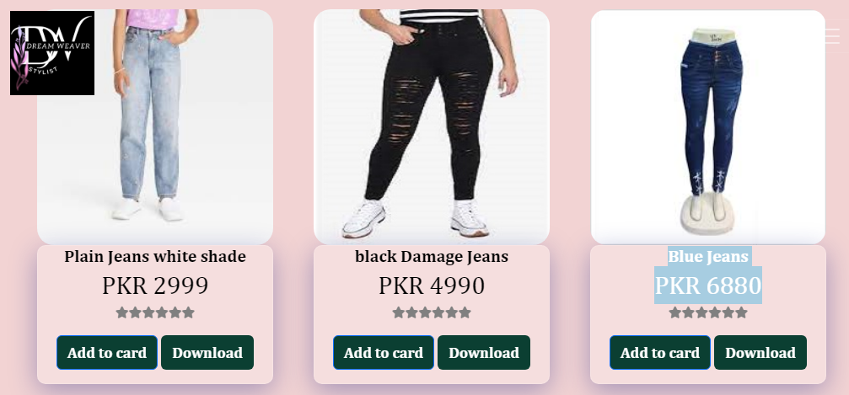

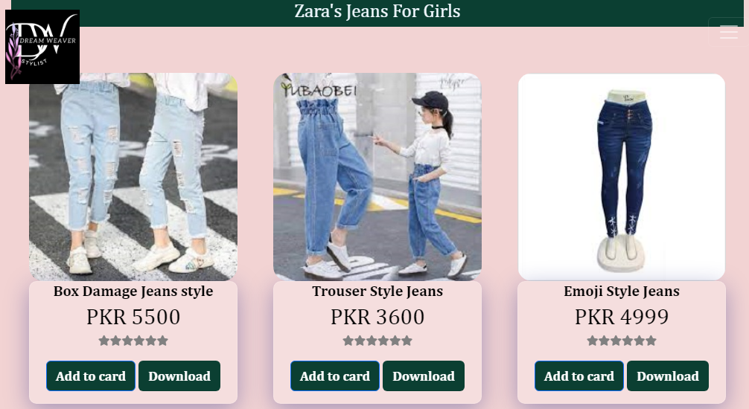

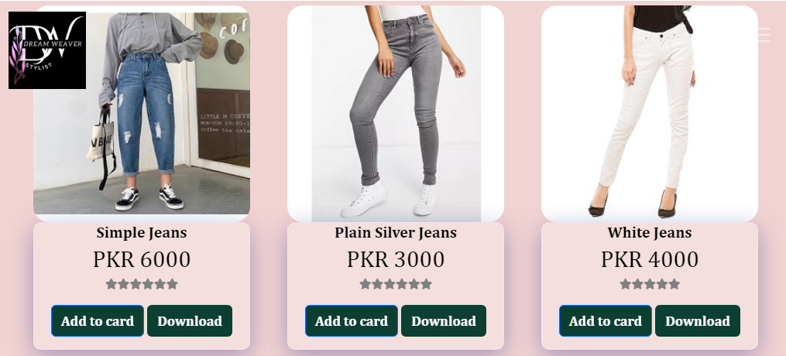

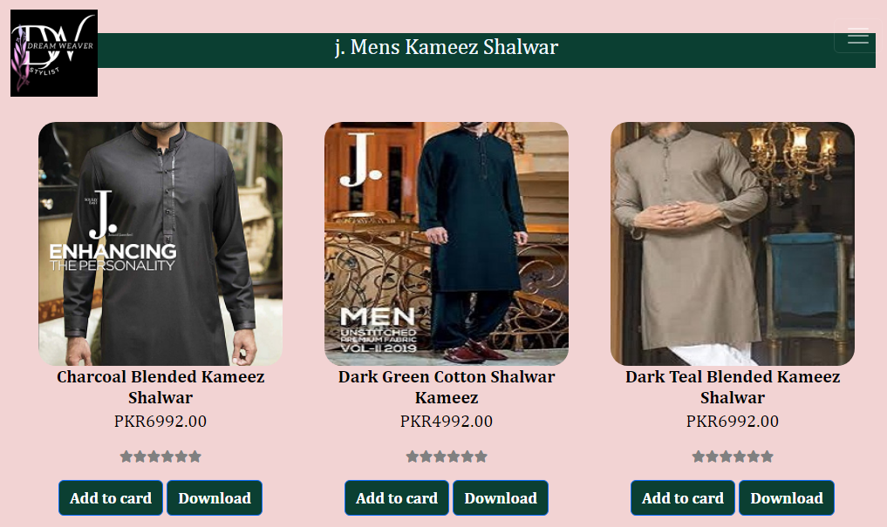

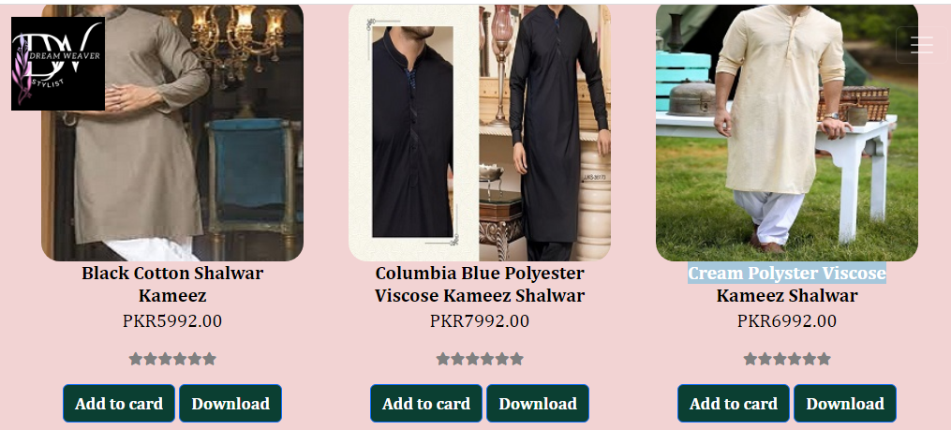

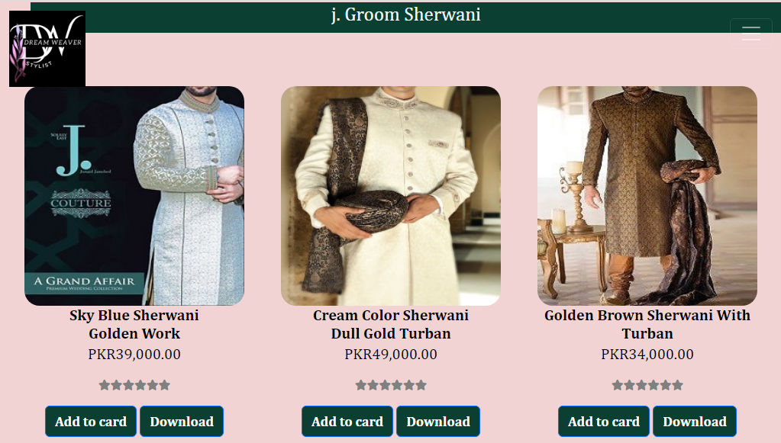

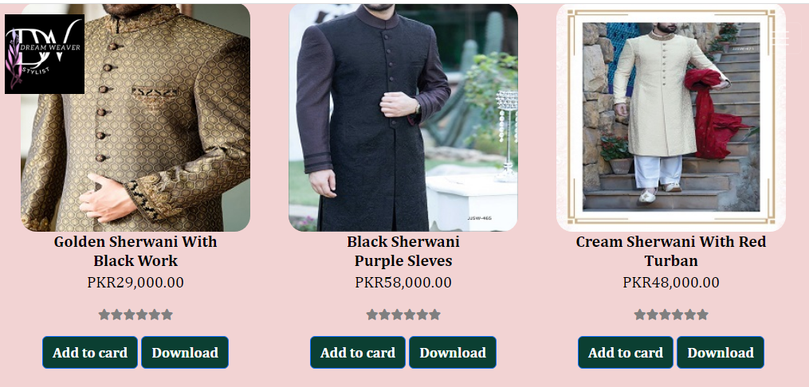

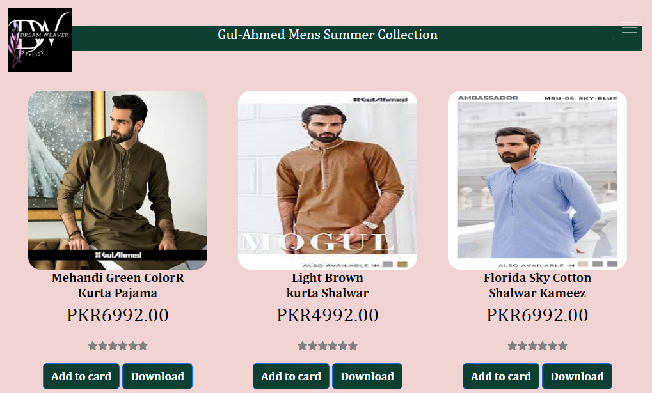

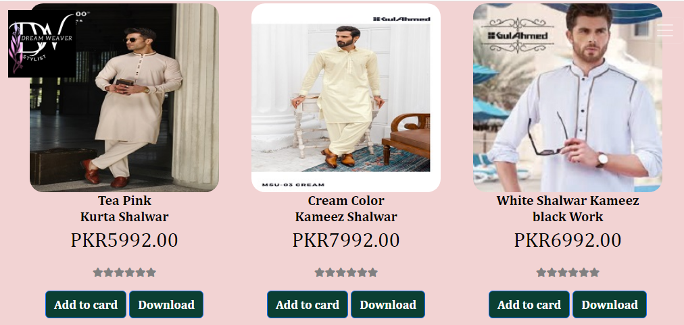

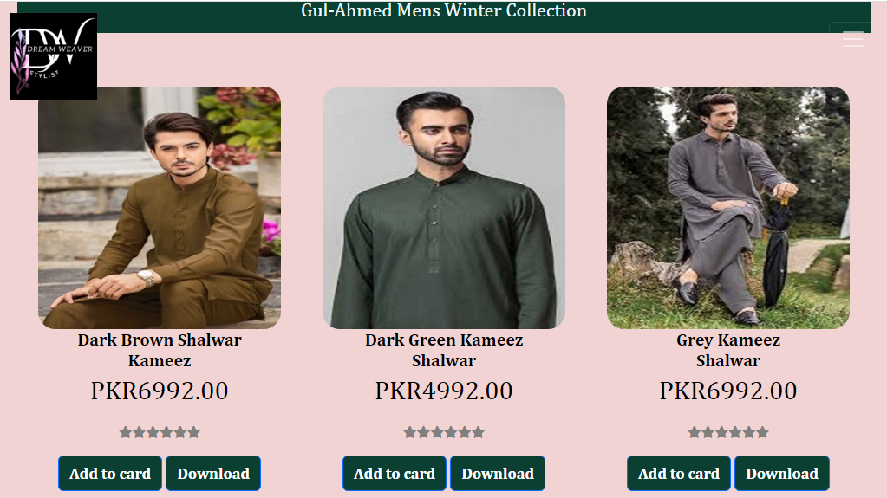

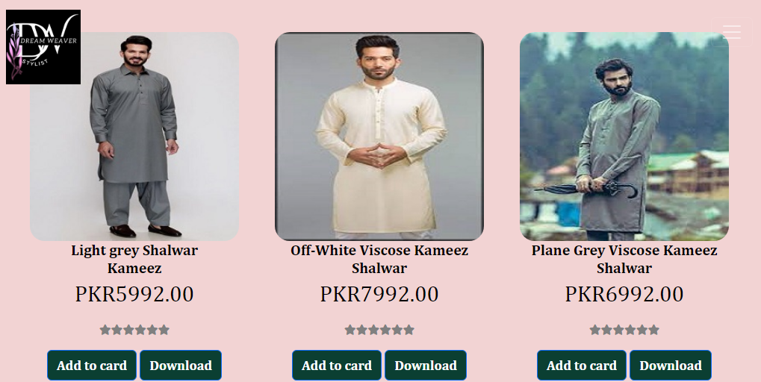

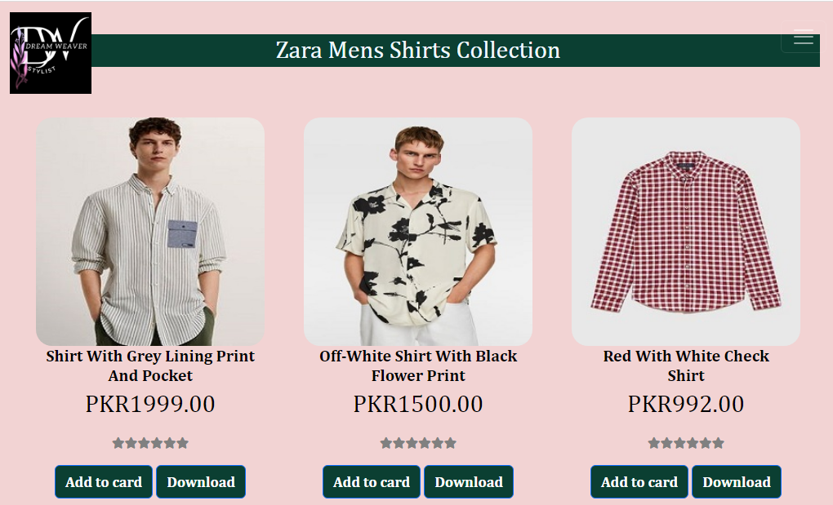

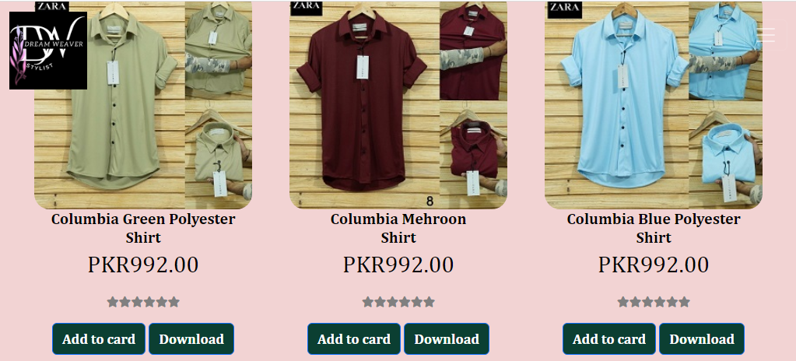

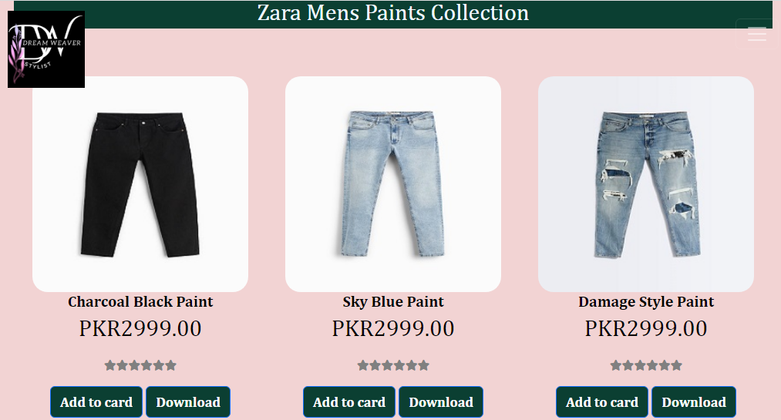

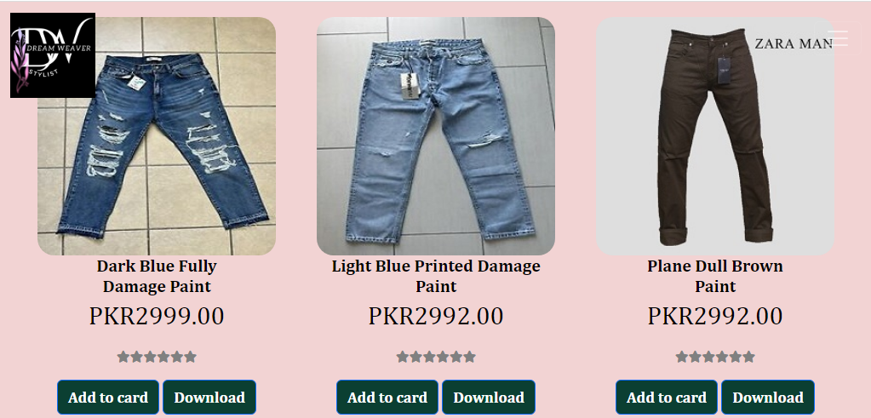

Detail Page

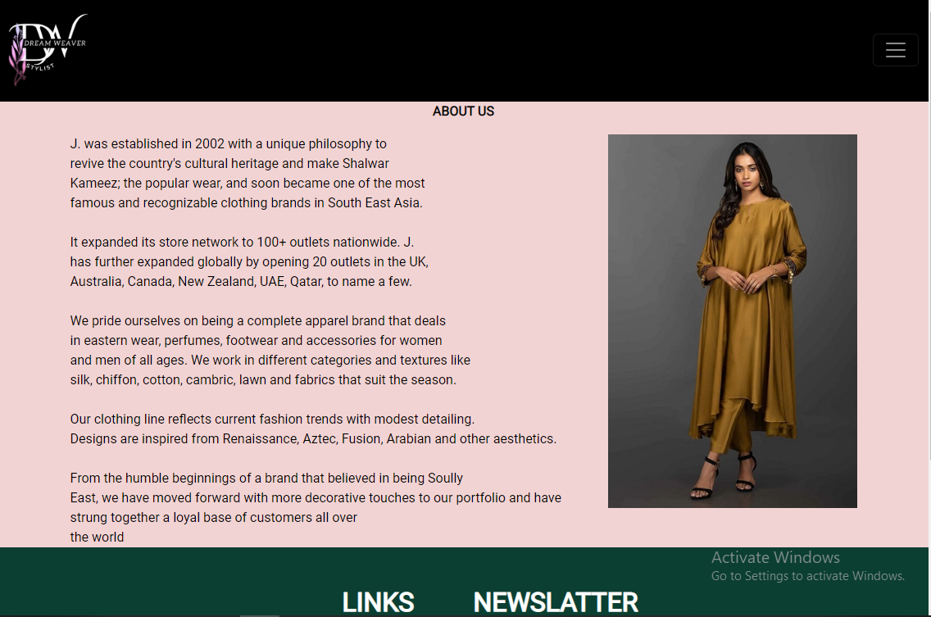

Contact Us Page

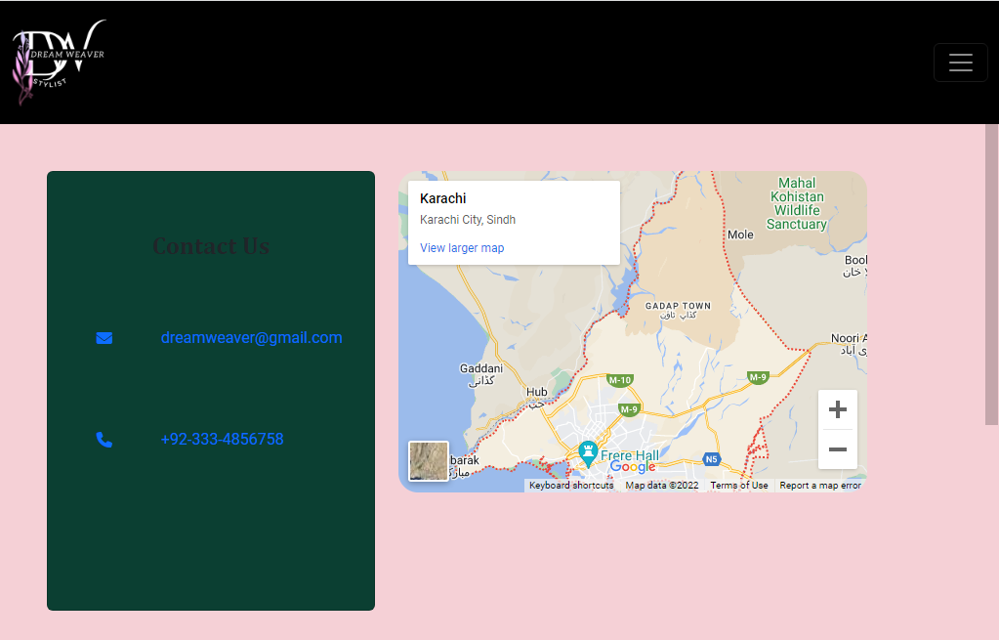

Comparing Page

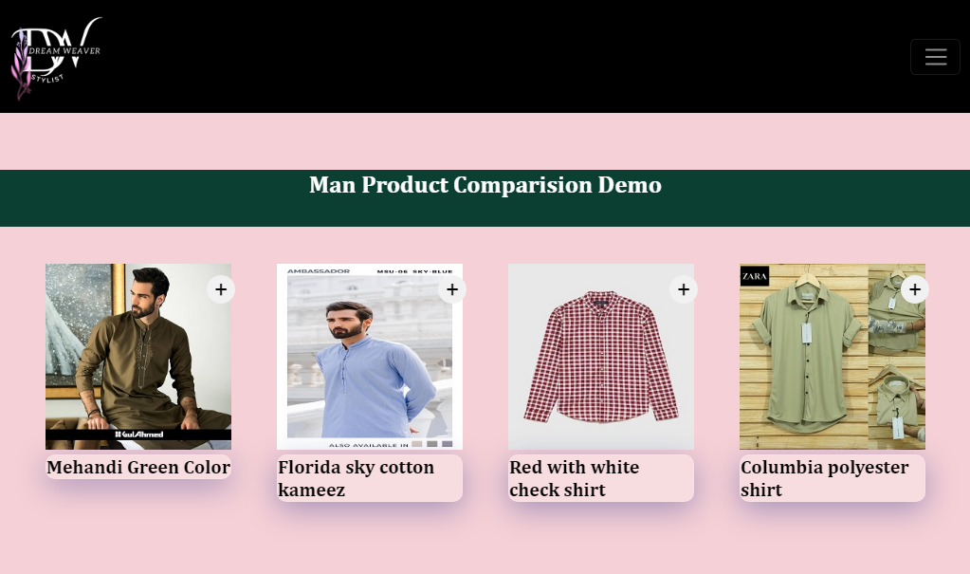

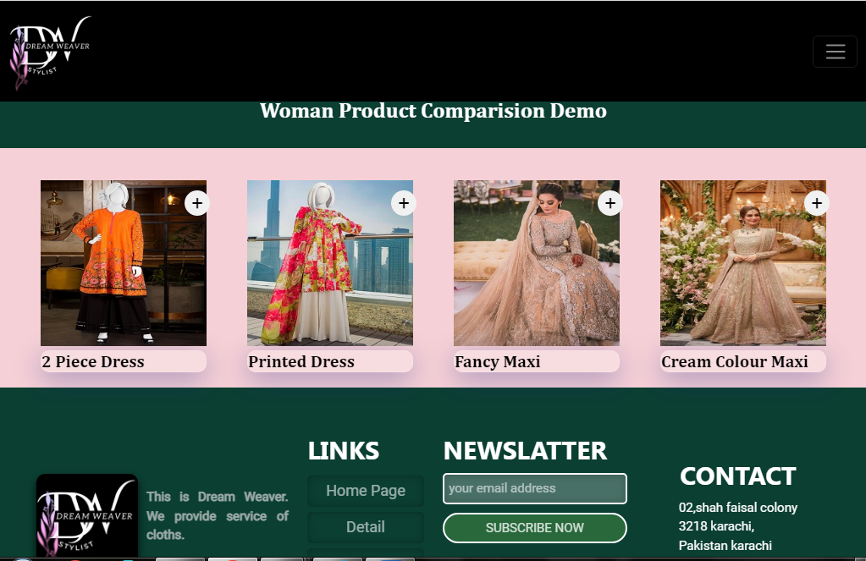

*OUR WEBSITE DREAM WEAVER “BY STYLIST IS ABOUT ONLINE CLOTHES SHOPPING”*

*ON OUR WEBSITE ALL THE SEASON CLOTHING COLLECTION ARE AVAILAB FOR Men&Womens WITH THEIR SIZE/COST/FABRIC ETC. ON THE WEB PAGE ALONG WITH THE PICTURE AND ON THE OTHER HAND WE ARE PROVEDING YOU A DETAIL FILE ABOUT THE MORE RELETABLE*

*SIZE/COST/FABRIC ETC.*

*TO MAKE OUR CUSTOMER BUY AN ARTICLE WITH THEIR OWN CHOICE.*

HOPE OUR WEBSITE HELP FULL TO YOU…!

# CONCLUSION